Practice 4 rollno:2520030022 name:AVSNRAkhila
SECTION 1: DDL
QUESTION 1: CREATE TABLE
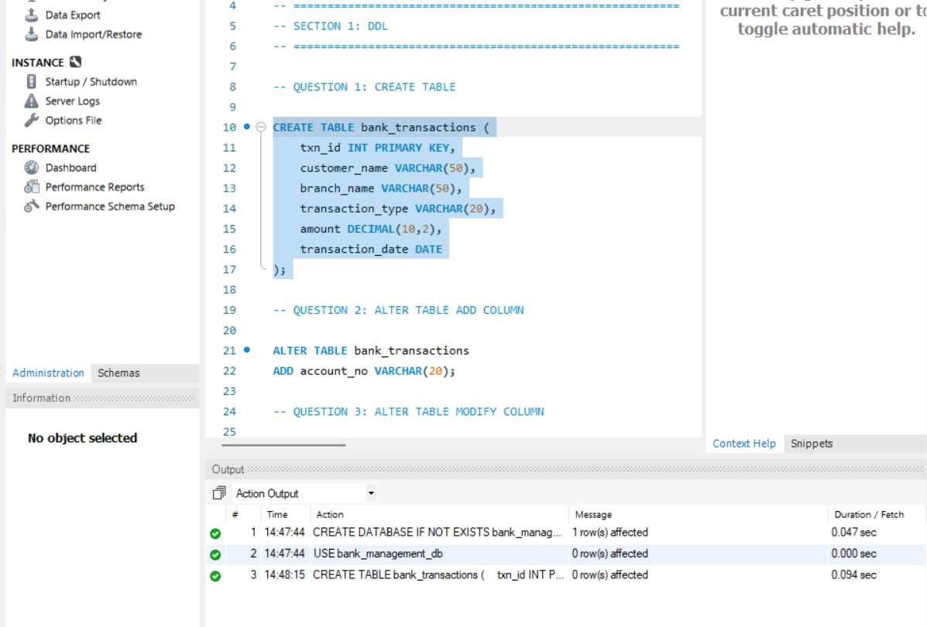
QUESTION 2: ALTER TABLE ADD COLUMN
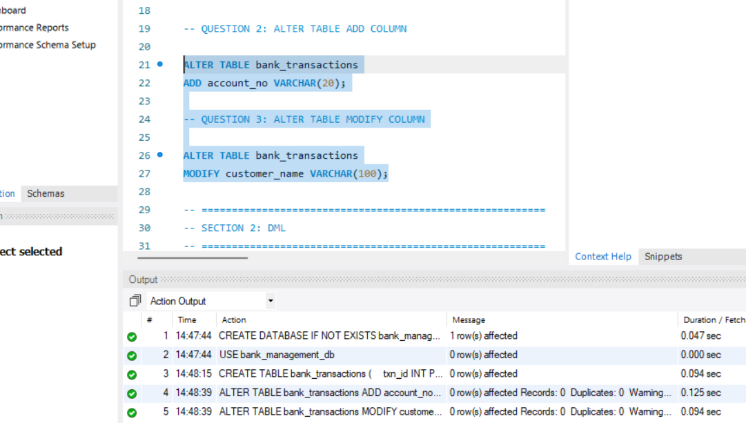
STEP 1: INSERT SAMPLE DATA
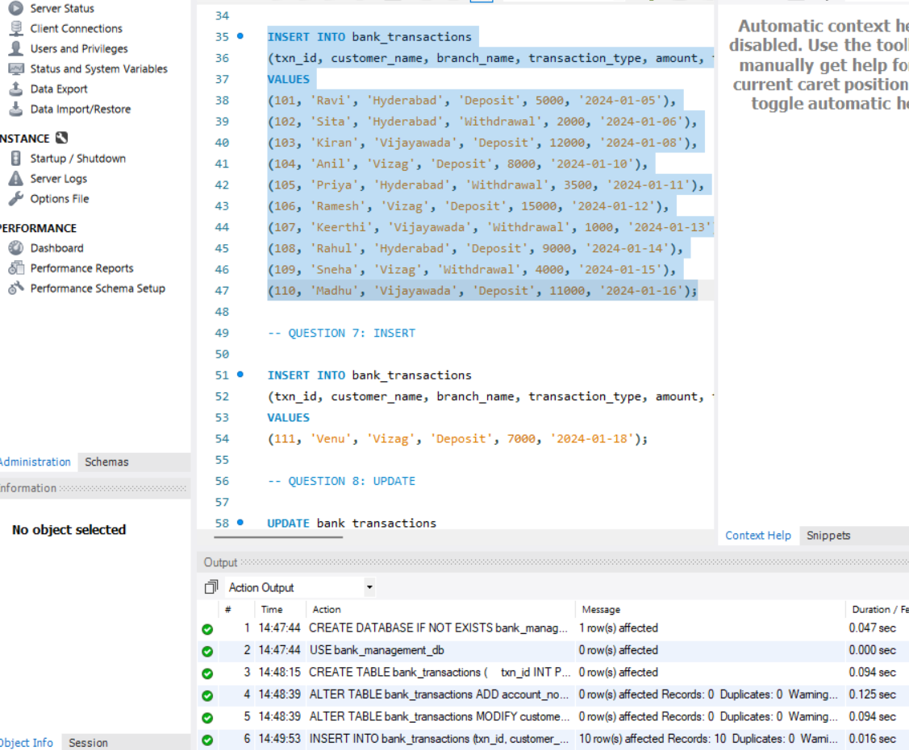
QUESTION 7: INSERT
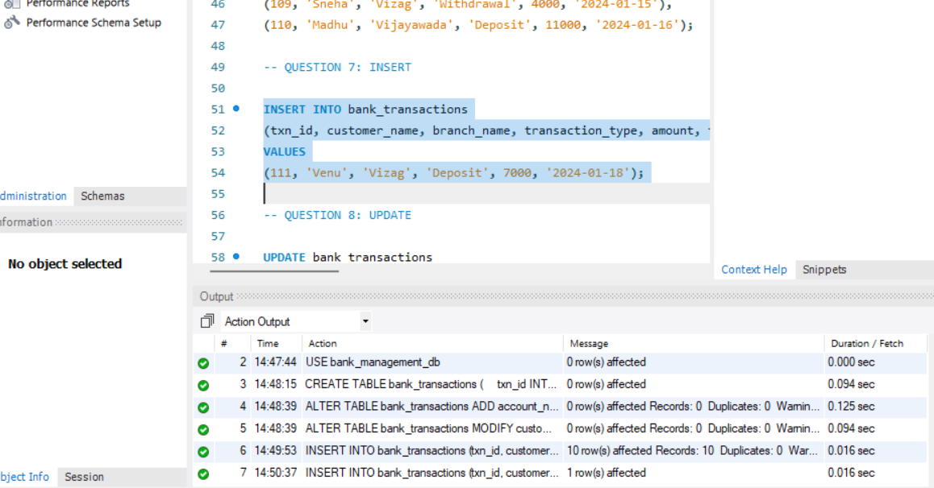
QUESTION 8: UPDATE
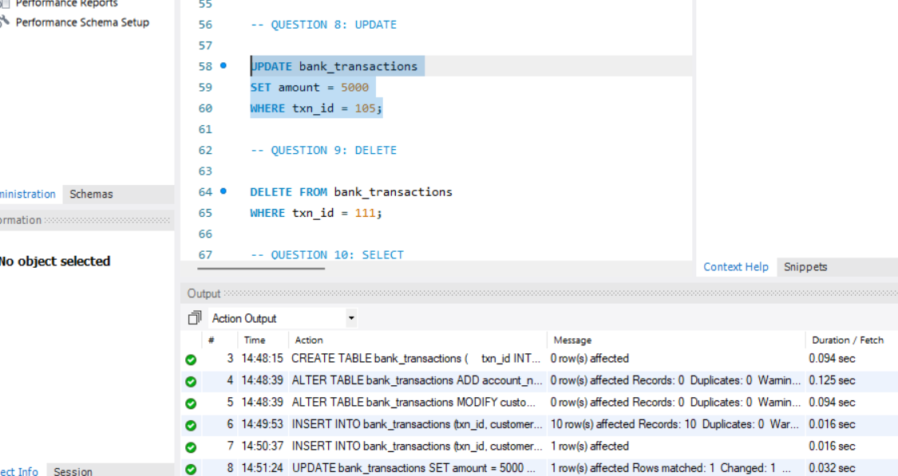
QUESTION 9: DELETE
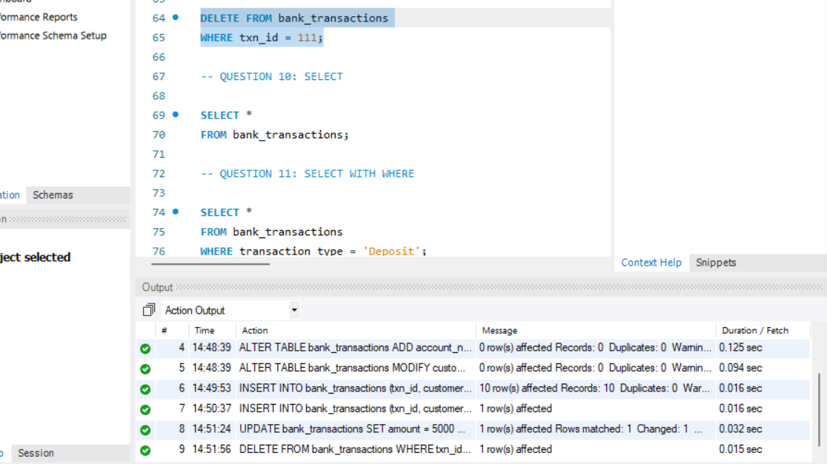
QUESTION 10: SELECT
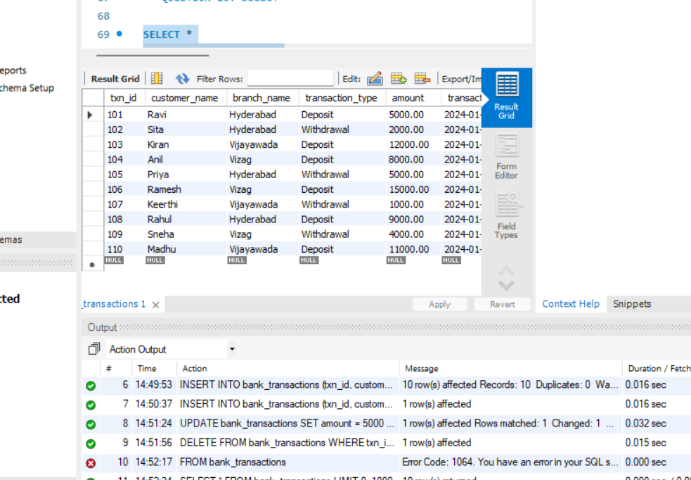
SECTION 3: DCL
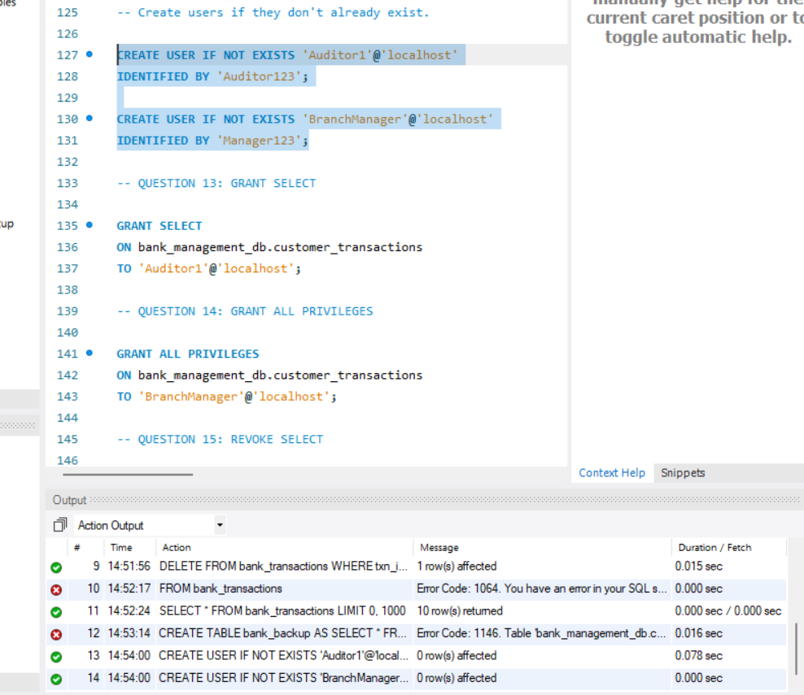
QUESTION 13: GRANT SELECT
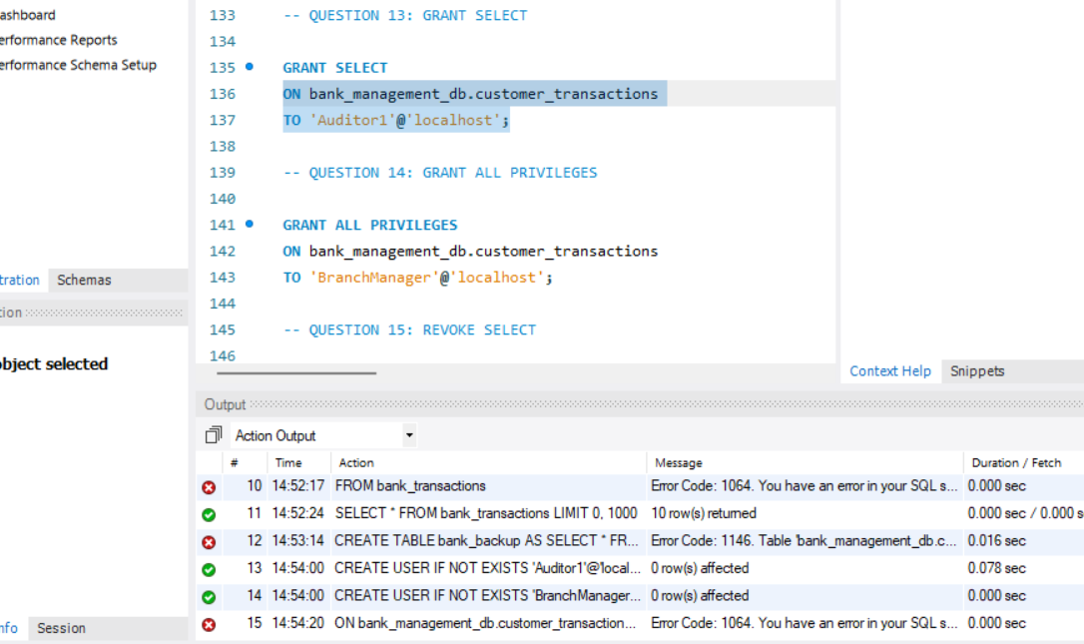
QUESTION 14: GRANT ALL PRIVILEGES
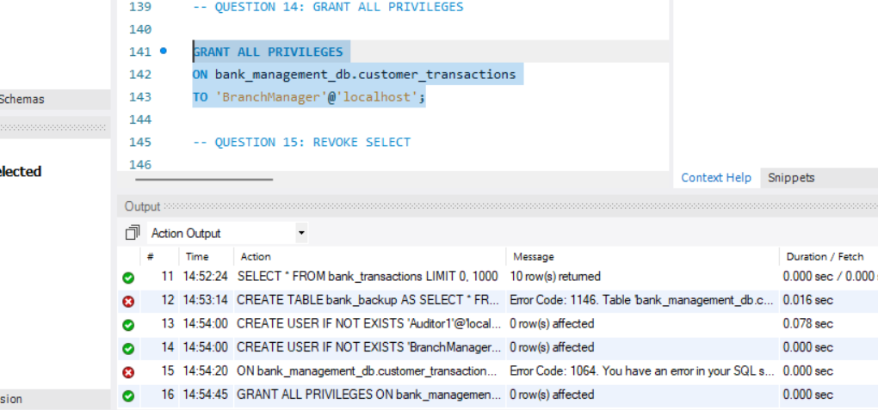
QUESTION 15: REVOKE SELECT
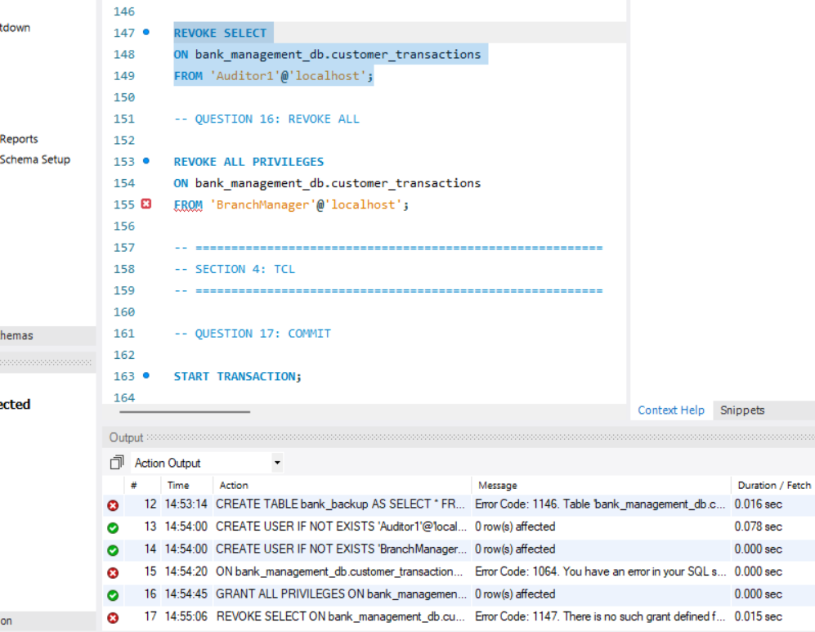
- QUESTION 16: REVOKE ALL
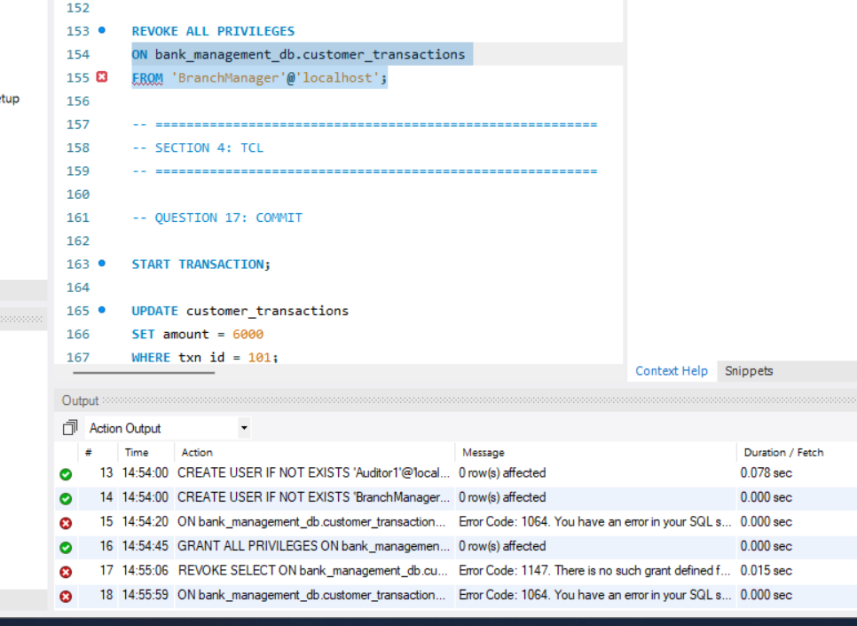
QUESTION 17: COMMIT
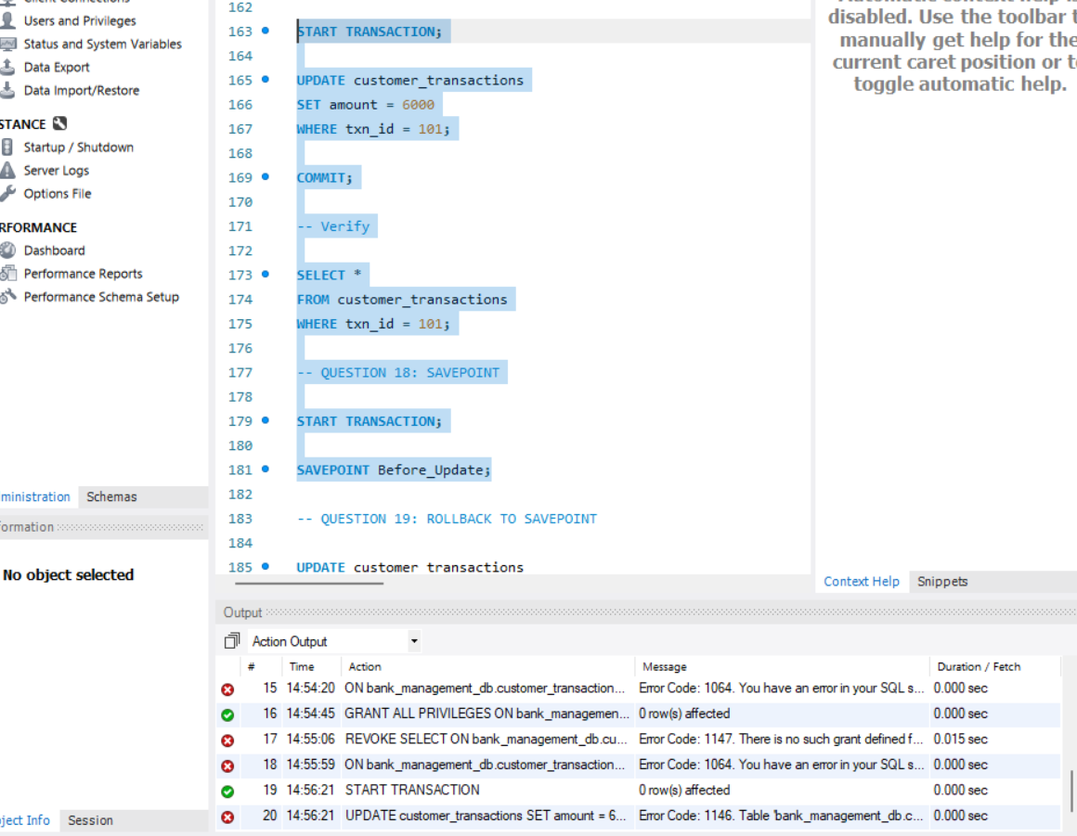
QUESTION 20: FULL TCL EXAMPLE
